EVENTS & RENTALS
PENINSULA SCHOOL OF ART
UPDATED 2022
Thank you for your interest in renting the facilities at Peninsula School of Art & Gallery. All venue rentals support PenArt’s mission to provide high-caliber, accessible visual art education programs, events and exhibitions for adults, teens, and children. Please see the information below to determine the spaces available and rental information. Don’t hesitate to reach out with questions.

ELIGIBILITY
- Peninsula School of Art & Gallery is available for rent to groups, organizations, businesses, and individuals ages 21 and over.
- Rentals are open as early as 18 months prior to your preferred rental date.
- Peninsula School of Art & Gallery facilities are not available for the purpose of offering fine art instruction.
- The acceptance of any rental depends on the availability of the gallery, studio, grounds, meeting spaces and staff.
- All rentals will be booked at the convenience of Peninsula School of Art according to previously scheduled commitments.
- An application form must be completed by the renting party.
- Since the Peninsula School of Art & Gallery is primarily an education and arts organization, we require all weddings and large events (75+) to work with an approved caterer and an approved event planner.

HOURS OF OPERATION
Peninsula School of Art & Gallery is open to the public during the following hours:
- Year-Round, Tuesday - Saturday, 8am – 5pm, and for scheduled events that are open-to-the-public.
- Excluding major holidays; holiday hours will be posted one week prior to holiday.
- Extended hours of operation are available to private renters upon approval. The following rental hours may be available after all events and classes have been scheduled. Sunday-Saturday, 8:00 a.m. – Midnight.
Note: All guests of the event must vacate the building by midnight. Renters must have building cleaned per policy and procedures. Music and use of a PA system will not be permitted after 11pm.

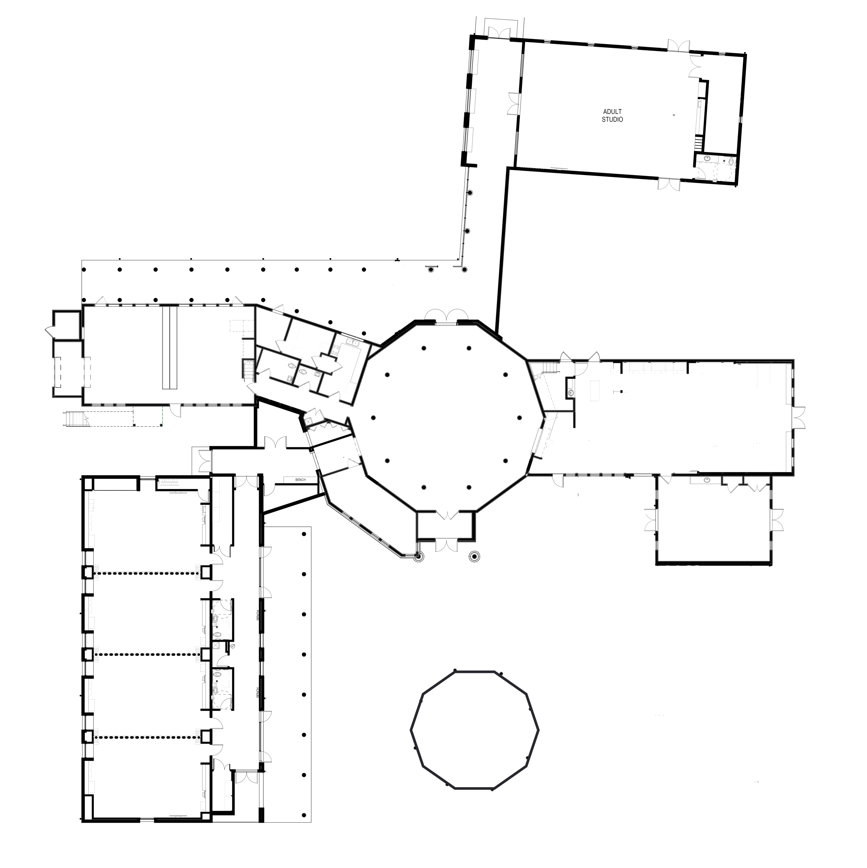
DESCRIPTION OF FACILITIES
GUENZEL GALLERY
GAZEBO
HAMMING ROOM
YOUTH WING
TOURTELOT STUDIO
GREAT LAWN
Peninsula School of Art & Gallery provides a variety of rental spaces on one accessible level.
- GAZEBO & ENTRANCE GARDENS: 30’ round structure, with brick floor and open sides. Space includes 10-4’ square tables, and 40 chairs. Space can accommodate up to 70 people for a wedding ceremony or theatre seating. Restrooms adjacent to the Gallery are available for renters of the Gazebo & Entrance Gardens.
- GUENZEL GALLERY: This exhibition space is large enough to accommodate 150 standing, or 100 as theater seating. The north wall of the Gallery features a pull-down video screen. The gallery is accessible from the Entrance Gardens and Great Lawn.
  - Note: Exhibition calendars are planned 12 to 18 months in advance and can limit the use of certain areas. For example, some exhibitions use space on the gallery floor or require the use of temporary gallery walls that affect the layout and floor space in the Gallery. Items on exhibit in the gallery cannot be moved.
- GREAT LAWN: The Great Lawn is available for rental in conjunction with a Guenzel Gallery rental. With room for a 60’ x 100’ tent, catering tent and outdoor power, this is an option for larger events or outdoor cocktail parties. However, all outdoor items will need to be rented and installed by an outside service provider.
- HAMMING ROOM (CONFERENCE ROOM): This space has a 50” flat screen, Apple TV, and a board room meeting table. This room has a comfortable seating capacity for 10 people at the board table, or 40 as theater seating.
- TOURTELOT STUDIO: A 1500 square foot space adjacent to the Great Lawn. This room can comfortably accommodate 75 people standing or tables for 100 and includes a restroom.
- YOUTH WING: An 1800 square foot space adjacent to the Guenzel Gallery. This room can comfortably accommodate 150 people standing or tables for 200 and include two restrooms and a 60” flat screen TV with Apple TV and soundbar. The space includes 20 - 6’ tables.
- KITCHEN: Complete with an oven, stove, refrigerator, microwave, sink and counter.
  - Note: This is a warming kitchen and cannot be used for meal preparation. Kitchen utensils are not supplied.
  - Use of the kitchen is included with the rental of the Guenzel Gallery or Great Lawn. The kitchen is available for an additional fee when renting the Gazebo & Entrance Gardens, Hamming Room, Tourtelot Studio or Youth Wing.
- TABLES & CHAIRS: Any tables and chairs, besides those outlined above are the responsibility of the renter. Unless prior arrangements have been made with Peninsula School of Art. All set up of rented tables and chairs (including PenArt tables and chairs) is the responsibility of the renter.
- LINENS: All linens are the responsibility of the renter.

FEES & RATES
- All events with hours after 5pm and on Mondays are required to have a PenArt staff member on premises to serve as Manager on Duty for the entire time of set-up through clean up of the Renter's event. The charge for the Manager on Duty is $50 per hour beginning at 5pm. The Manager on Duty is not responsible for event set up or clean up, but rather to ensure the safety of the facilities and artwork.
- The set up of any tables, chairs, catering equipment or other materials in a space constitutes use of the space and the Renter will be charged accordingly.
Tourtelot Studio, Great Lawn, Gazebo, Gardens, Guenzel Gallery, Kitchen | Wedding/Event Rentals | $8,000
Youth Wing, Great Lawn, Gazebo, Gardens, Guenzel Gallery, Kitchen | Wedding/Event Rentals | $8,000
*Weddings and Large Event Rentals can choose between the Youth Wing or the Tourtelot Studio in addition to the Gallery, Gazebo, Kitchen, Lawn and Gazebo.
*For small group facilities rentals, contact Sarah at Sarah@PenArt.org

RENTAL & USE POLICY

BOOKING TIMELINE/CONTRACT PROCESS
- Booking Date: The Peninsula School of Art is available for booking 18 months in advance. Renters are encouraged to call ahead and gather rental information, visit our facility and discuss the details of the rental process.
- Rental Application: After reviewing the Rental & Use Policy Document, applicants must complete the Rental Application form at least four weeks (28 days) in advance of request date. This form can be emailed, mailed, or dropped off to PenArt. This application form is to be completed by the individual who is to be on site at the event and must be 21 years of age or older. Applicants will be notified within 14 days of receipt of application.
- Payment: For events at Peninsula School of Art & Gallery, staff will issue an invoice and rental contract as soon as the application form is approved. A 50% non-refundable deposit is due within ten (10) days of issuance to secure the date. Payment can be made in cash, check, ACH or credit card payable to Peninsula School of Art. While credit card payment is available, cash, check or ACH is preferred. Remaining balance is payable 30 days prior to the event rental.
- Insurance Requirements: A certificate of insurance is required for special open to the public events serving alcohol. For events open to the public, provide a Certificate of Insurance, showing liability limits of $1,000,000 naming Peninsula School of Art as an additional insured must be provided one week prior to event. A certificate of insurance can be obtained through Homeowners or Business Liability Insurance.

CANCELLATION POLICY
If a cancellation is made:
- All deposit fees are non-refundable.
- All cancellations must be submitted in writing. All fees and dates are non-transferable.
- There are no refunds for cancellations less than 30 days before the event date. Cancellations made more than 30 days before the event would receive a refund of monies paid minus the 50% nonrefundable deposit.
SET-UP AND DECORATING
- Event Contact: The person/organization signing the rental contract must be present from the time the building is opened or event set-up begins, while the event is in progress, and must wait until all event guests have vacated the premises and has met with the staff on site. If they are not able to be present, they will need to provide a responsible party to be the point of contact. For youth groups, rentals will be issued only to responsible adults who chaperon the party. An adult chaperon is required for every 20 youths. A list of chaperons with addresses must be presented when the Rental Use Application is completed. The chaperons must remain on site until the event has completed.
- Set-Up: All tables, chairs and other equipment brought in by, or for, the renter and/or caterer are the responsibility of the renter. PenArt staff will not be responsible for the moving, setting up, or taking down of any equipment.
- Decorating: All decorations must be put up and taken down by the renter and must be free standing. Nails, tape, tacks, staples and screws are strictly prohibited. Glitter, confetti, rice, silly string or natural flower petals are not allowed at any time. Helium balloons are not allowed indoors.
- Candles: The only open flame allowed in the Peninsula School of Art are small votive candles with an adequate glass covering of at least 2” of headspace. They must be approved by the PenArt staff prior to the event.
- Signage: Signage may be displayed on portable sign holders, bulletin boards or easels.
- Decor Removal: Any materials or equipment belonging to the renter must be removed from the facility and grounds at the conclusion of the activity unless written permission has been granted for storage.
FOOD SERVICE
- Self-Catered: Food may be prepared at home and brought to PenArt. However, renting group must follow clean up guidelines.
- Kitchen: A warming kitchen is available for the renter’s use at an additional charge when not renting the Gallery or Great Lawn. Included in this fee is the use of all major kitchen equipment including refrigerator, freezer, oven, stove top, microwave and sink with garbage disposal. No service ware, glassware or utensils are provided. Renters must bring their own soap, dishcloth/towel and other clean-up supplies. If you use the kitchen yourself, you must clean it and check in with a staff member before you leave.
- Caterers: Food may be provided by a caterer. A caterer is defined as providing food and service for events at a professional capacity. Caterers may be contracted once they have completed the application, provided proof of applicable licenses and insurance and received approval.

ALCOHOL
If you plan to have alcohol at your event, a license and service staff may be required. Please contact the Town of Gibraltar for rules and regulations. clerk@gibraltarwi.gov - (920) 868-1714

CLEANING
Users leaving the facilities in a manner that require more than customary cleaning will be billed $80.00 per hour to cover added costs. Customary cleaning includes: cleaning of the restrooms, mopping of the floors, vacuuming of carpeted spaces and emptying of outside dumpsters.
The renter’s cleaning responsibilities include: removal of any and all items brought into the Peninsula School of Art by the renter. Renter must wipe down tables and chairs if necessary. Renter must clean the kitchen if rented. If hiring caterer, they are primarily responsible for cleaning kitchen. If you plan to bring your own food and use the kitchen, you are responsible for cleaning the kitchen. Any damage to the facility upon inspection by Peninsula School of Art staff will be billed to the rental to include all time and materials for the repair.

LITTER/REFUSE/RECYCLING/COMPOST
The applicant and / or group will be responsible for any and all damage to Peninsula School of Art. Any litter or refuse generated by the group and activity must be collected and disposed of in appropriate trash/recycling receptacles and removed to the dumpsters outside of the building at the conclusion of the reservation - either by the caterer, event planner or the renter. Peninsula School of Art may assess a fee for damages or additional cleaning if the area is not returned to original condition and reserves the right to deny future applications if these conditions are not met.

PARKING
There are 60 asphalt parking spaces at Peninsula School of Art, in addition there is an overflow gravel parking. If supplies must be dropped off, the service entrance may be used. Supplies cannot be loaded in the front door without prior approval. The vehicle must be moved to an appropriate parking location immediately after unloading.

OTHER GUIDELINES & RESPONSIBILITIES
- Peninsula School of Art is not responsible for any equipment or other items left at PenArt at any time.
- Smoking is prohibited inside the building, on the porches, and within 50 feet of the building at all times.
- The renter assumes all responsibilities for injuries that may occur to persons or participants.

SINGLE USE PLASTIC & STYROFOAM
Peninsula School of Art & Gallery strives to minimize our impact on the environment and discourages the use of single use plastic water bottles, plates and cups. Styrofoam products are not permitted.

USES REQUIRING SPECIAL CONSIDERATION
Special provisions or requests may be required for the following events. Any rental requiring additional provisions is subject to all rules and guidelines outlined throughout this document.
- Gatherings for the purpose of advertising, sales, solicitations, or the display of articles for sale: ordinance. Prior to any retail or wholesale sales, the vendor must provide copies of permits and licenses required by Town of Gibraltar. PenArt may require the vendor to give notice to all purchasers that Peninsula School of Art in no way warrants or guarantees any product or service being offered for sale at the Peninsula School of Art & Gallery.
- Fundraising Activities: Fundraisers are only permitted to benefit local or non-profit organizations. Applications should include:
- Name under which the individual/organization intends to conduct the fundraising.
- Names and addresses of all responsible parties.
- General purpose for which the organization/group is organized and purpose for which the contributions will be used

